

To whom it may concern:

This letter is in support of Dr. Tarek Loubani's application to the Western Office of Research Ethics for application REB 107952.

Dr. Loubani is a physician in good standing in the Division of Emergency Medicine, and will be running a study to calibrate and validate a low-cost high-quality pulse oximeter that he hopes will meet or exceed a gold standard device.

I have agreed that Dr. Loubani may use any relevant resources in the Department of Emergency Medicine for this study.

If you have any further questions, please do not hesitate to contact me.

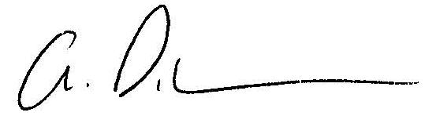Sincerely,

______________________________________  
Adam Dukelow MD, FRCPC, MHSC, CHE

London City-Wide Chief and Western Division Chair Emergency Medicine

Associate Professor Medicine, Western University

Medical Directory of Innovation - SWORBHP